Checking Baler Dump Data with Cimarron
Ver. 1.1 2008 05 06 aws
- Attach hard drive w/ data from a batch of Baler dumps onto PC
- Run Cimarron:
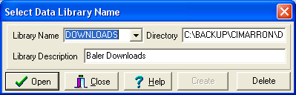
- Click “Open”
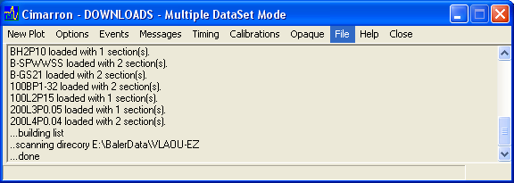
- Drop down the File tab and choose “Index miniseed files”
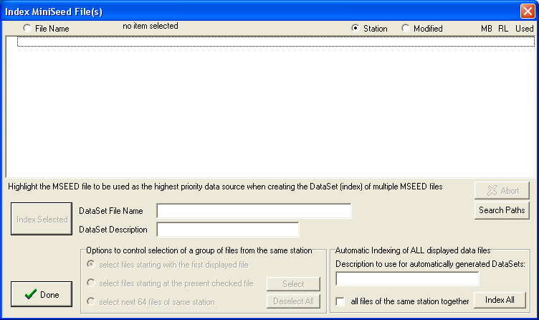
- Click on “Search Paths”:

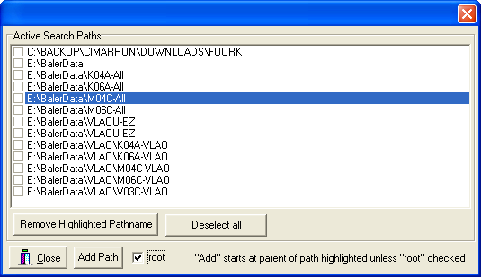

- Click on “Add Path” with root checked.
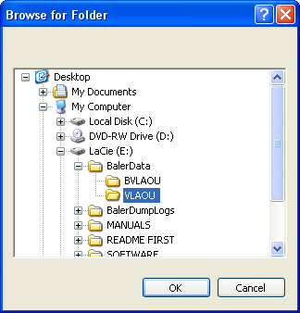
Navigate to where VLAOU data is and click “OK”
- Click “Close” on original Search Paths box shown below: 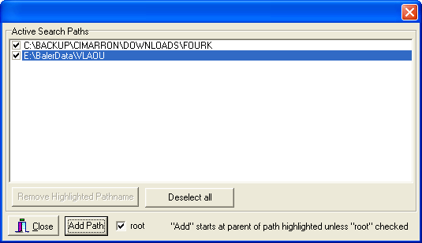
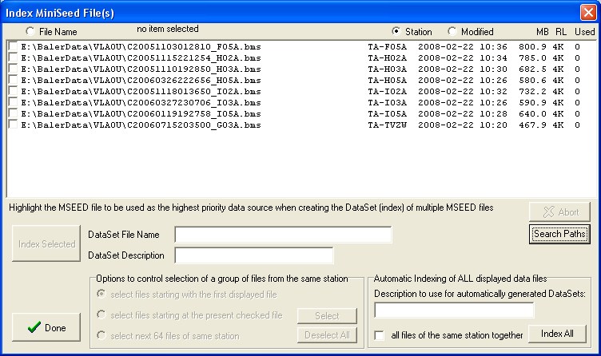
- Now, check the first file to examine:
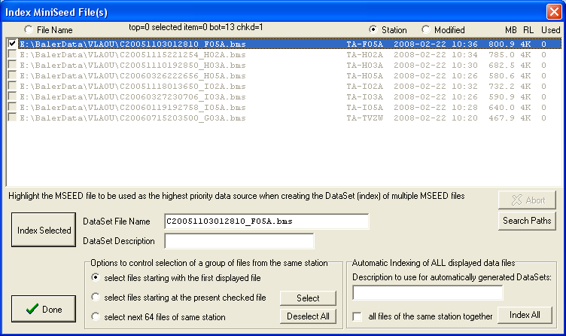
- Click “Index Selected” in the box above. If the following box shows up, click Include Data from foreign stations, then click “Apply”
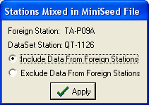-
- It takes about 3 minutes to index 100% - when done, click “Done”
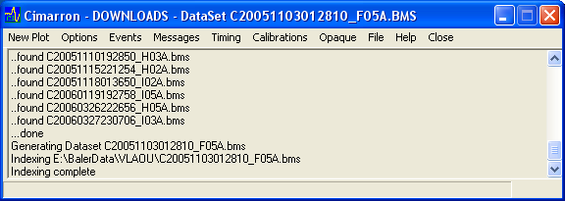
- Now Click “New Plot”
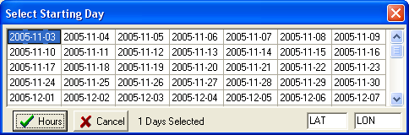
- The first day is highlighted. Scroll down to the bottom of the page, hold Shift and Left click the lowest right square
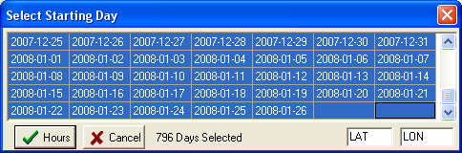
- Now Click “Hours” – wait a bit, then the following screen appears:
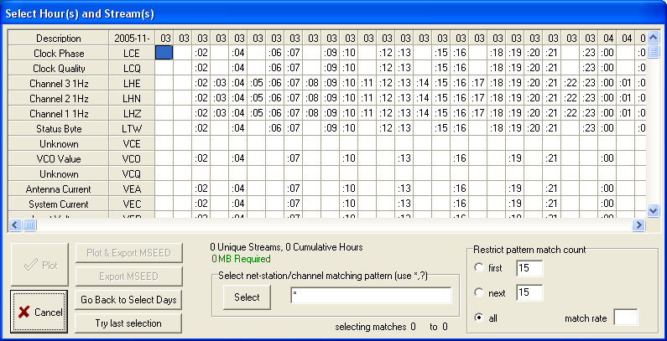
- Click on the VHZ:
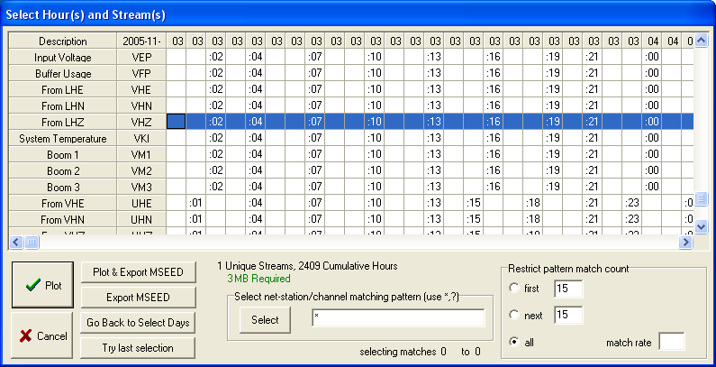
- Click “Plot”, then a plot of the data will appear:
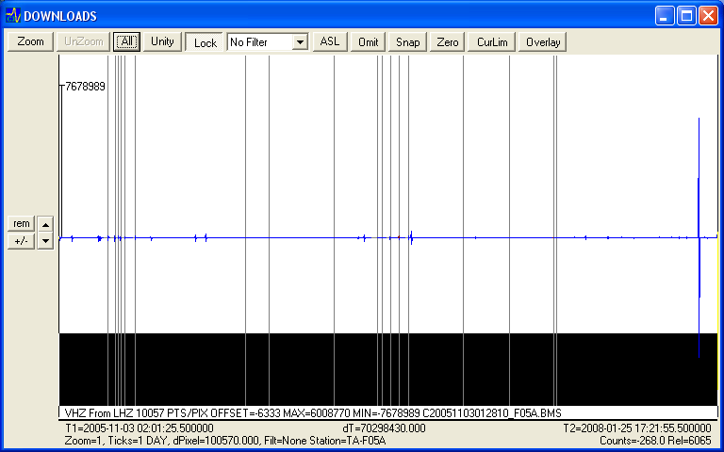
- Check that the blue line is continuous. Move the Left cursor to the far left by clicking on it and holding the clicker down and dragging it left, and move the Right cursor to the far right by clicking on it, holding the click down and dragging it to the far right. Check that the start and end time (T1 and T2) match that given in the Word document that had the screenshot from EZ baler:
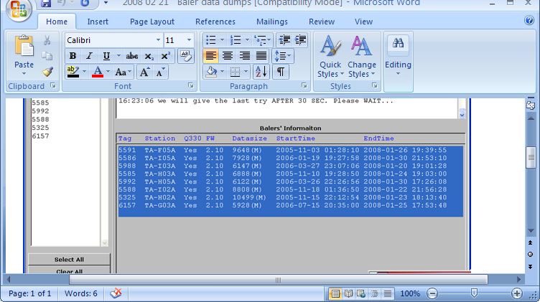
- Start time of 2005-11-03, and end time of 2008-01-26 matches in both, there are no large gaps to report, so F05A is checked ok. Close the Cimarron plot file by clicking on the Upper right corner X. The Cimarron window will below will appear:
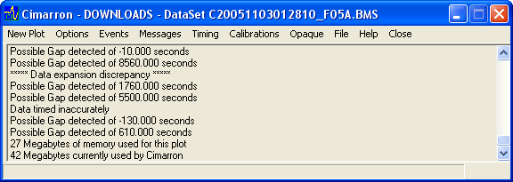
- Click on “File” “Index miniseed files” again to see:
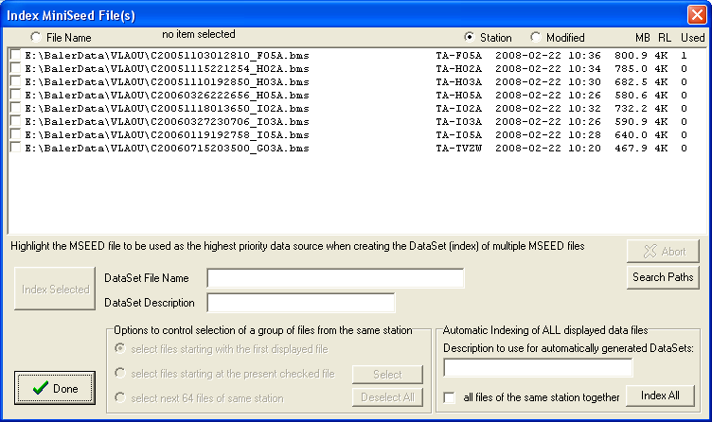
- Click on the next station file and then click on “Index Selected” and repeat steps 8- 18 for each station.
- After all the data is scrutinized with Cimarron, make an identical copy of the LaCie disk on another LaCie disk – (Baler Data and Baler Dump logs directories). Attach large Avery Labels to each hard drive and title it: TA Baler Final Dumps yyyy/mm/dd (current date).
- Print on each label the station names of the data dumped and at the bottom, label the first drive PIC, and the copy drive ANF.
- Then open up 4 cygwin windows by clicking on the black C with a green arrow pointing right:
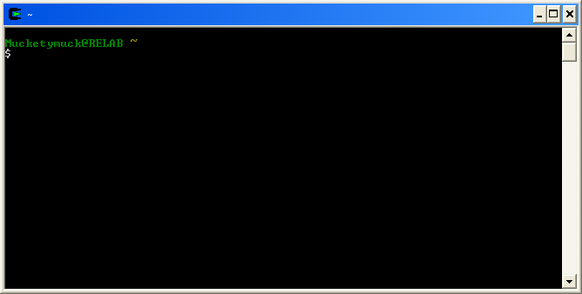
- In one of the cygwin windows navigate (using the “cd” command) to the original BalerData/VLAOU directory, in another cygwin window, navigate to the copied disk BalerData/VLAOU directory. In the other 2 cygwin windows, navigate to BalerData/BVLAOU on the 2 drives.
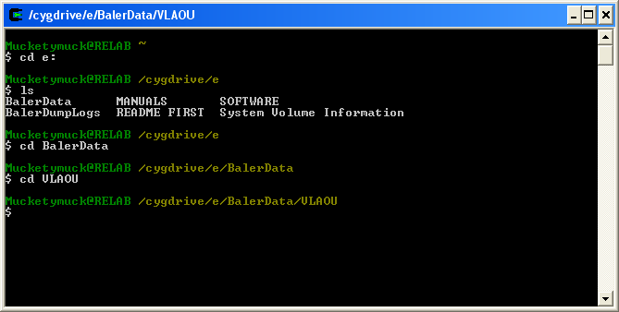
- Run:
cksum C* > cksumVLAOU1
in the first VLAOU directory, and in the second cgywin window run:
cksum C*> cksumVLAOU2
in the VLAOU directory on the other hard drive. Repeat commands, changing VLAOU to BVLAOU in the other 2 cygwin windows.
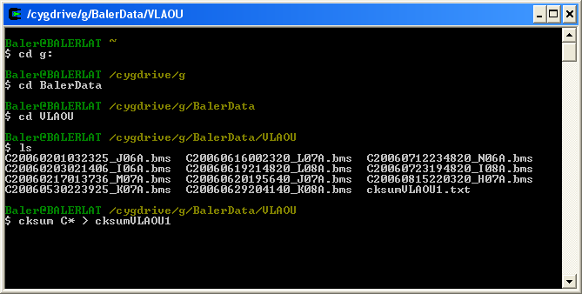
- Do the same cksum command on each directory: ANF VLAOU, ANF BVLAOU, PIC VLAOU, PIC BVLAOU
- Once these cksum files exist, type the 2 following commands in one of the cygwin windows (doesn’t matter which one):
diff /cygdrive/e/BalerData/VLAOU/cksumVLAOU1 /cygdrive/f/BalerData/VLAOU/cksumVLAOU1
diff /cygdrive/e/BalerData/BVLAOU/cksumBVLAOU1 /cygdrive/f/BalerData/BVLAOU/cksumBVLAOU1

